Table of Contents
React 💡 📡💡💡...Key Brain storm Points 1
Tailwind CSS: (2019) 19
React 19 19
GraphQL 19
What and why GraphQL ? 19
OperationTypes in GraphQL 20
GraphQl Big Picture Compared to REST apis 20

React 💡 📡💡💡...Key Brain storm Points

1.Render can only return 1 HTML div container.
Add more html or JSX content inside that div container per every render.
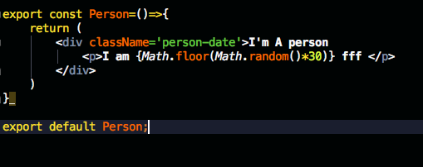
2. Looks like the setState has an issue with scope and only works for ES6 arrow function.
3. Do not use arrow function to bind the methods in the JSX template. instead use javascript .bind(this,args).

React Framework:
React.renderer( ); is the key , mostly used to render the JSX code on DOM.
JSX: -----HTML in javascript code
Let’s get Started:
Basic demo react application: Codepen: https://codepen.io/anon/pen/MELQaQ
Module 1: Next Gen JavaScript (Es6 & Es7)
Let and Const:
Const are variables that do not change.
Let is the new var . They mainly focus on scope of the variable.
Arrow Function:
Another way to create a function in Javascript.

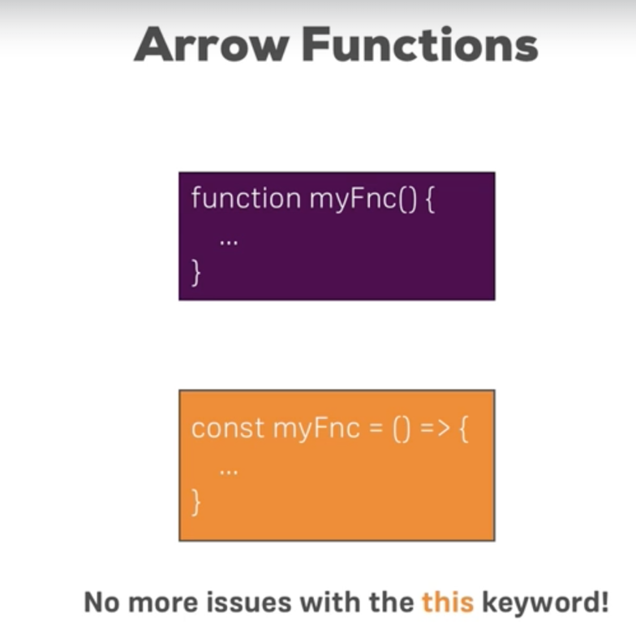
Export and Import:
To import content of another file in a JavaScript. (We can declare and create interfaces or common const and classes that are used across various file in the modules).
2 ways to import in the content:
For a file we can have a default export or we can import by the name(clean import).
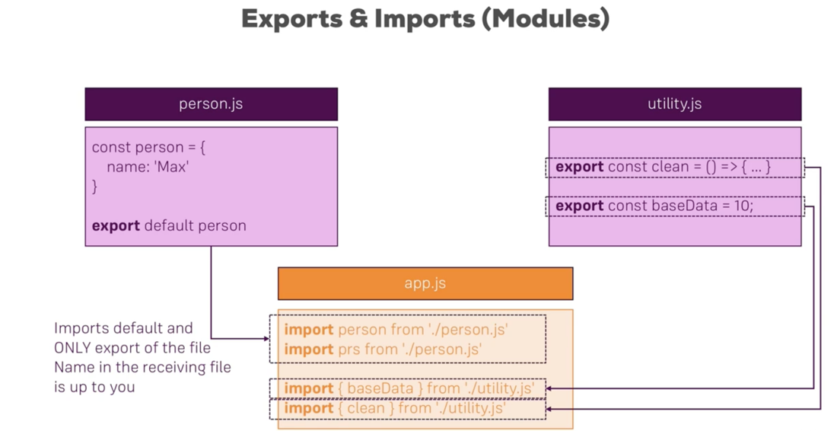
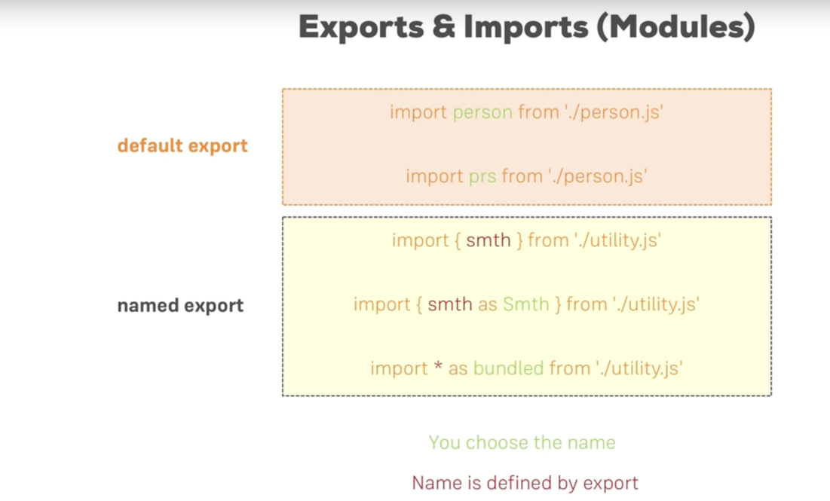
We can import Everything using a ‘*’ and add ‘as’ . for aliasing the import. Default exports do not have {name}, but named imports has to be inside the { }.

Classes:
Classes are essentially blueprinting of objects. Classes have properties and methods. Methods are essentially functions attached to the JavaScript classes and properties are variables attached to classes.

Classes also supports inheritance. which is also called prototyping in JavaScript.
Constructor is instantiated or executed when the class is instantiated.

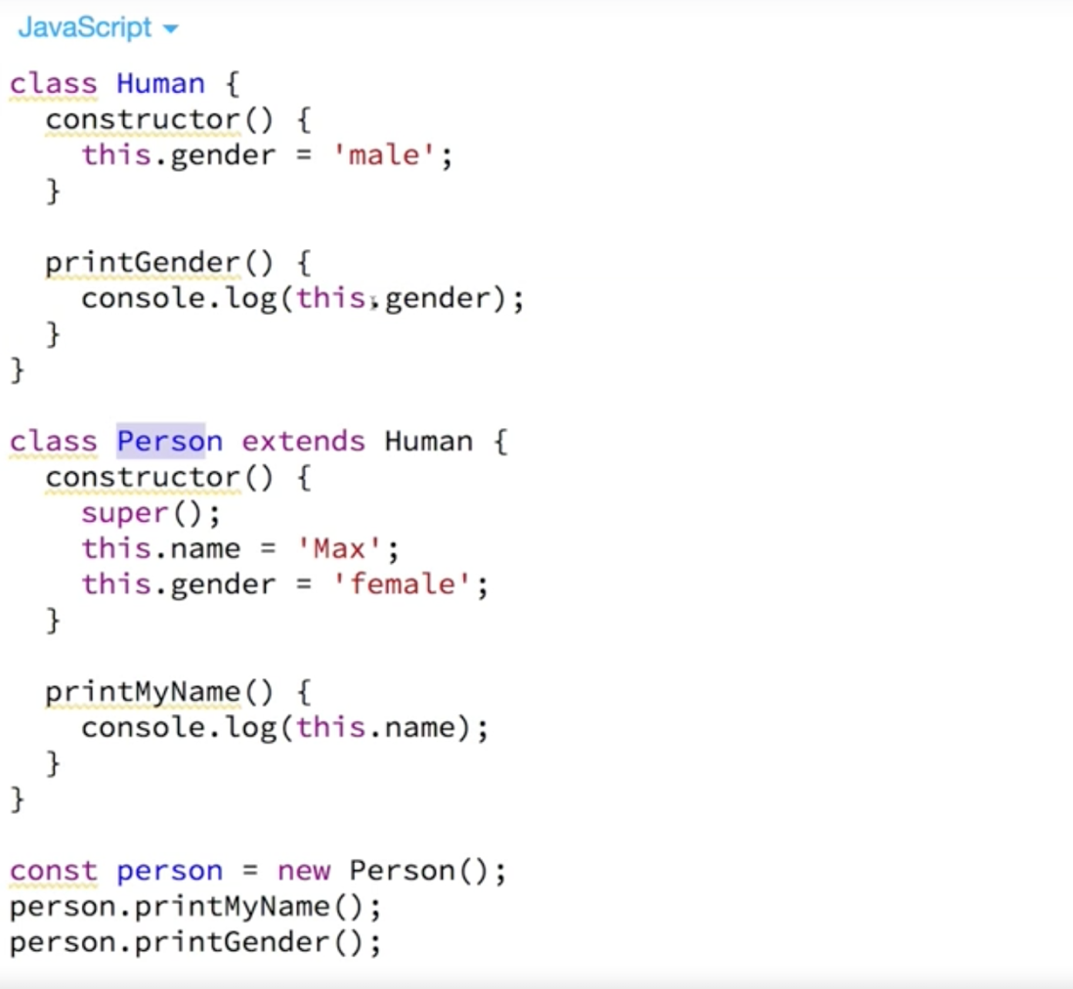

We can extend the classes using extend key word and when we implement the constructor in the child class we must add the super keyword. This is only if we are implementing a constructor in the child class

Advance syntax for declaring the properties and methods.
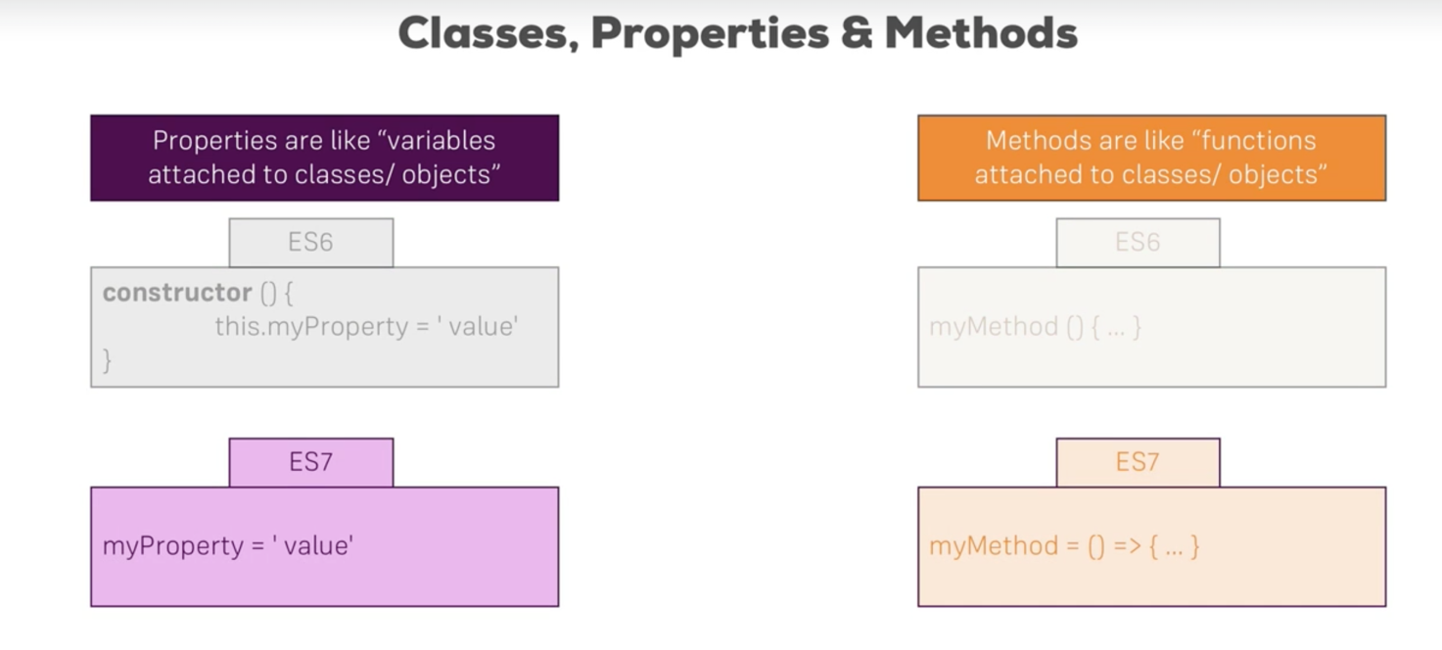
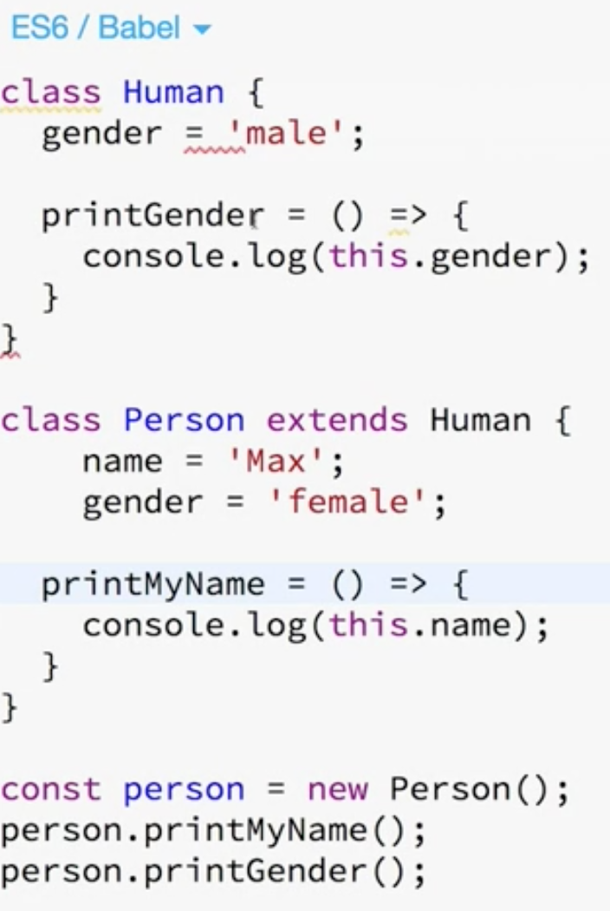
We no longer need to have the constructor to declare the variable and we can use arrow function syntax to declare the functions.

Arrow function by default adds the ‘return’ statement.

Spread Operators and Rest Operators: …

Spread: ....Create a new array or object and add them to the new array and object.

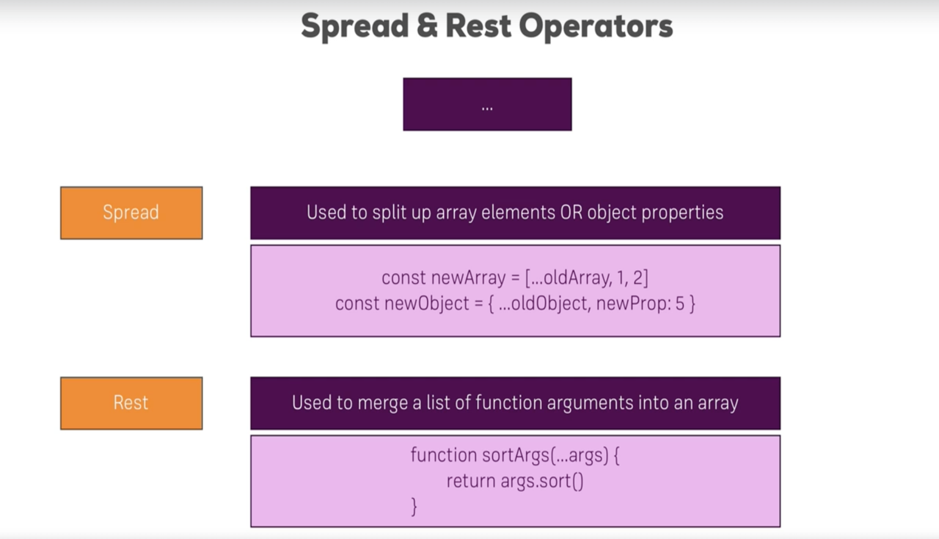
Rest operator is where we add only one argument ‘(...arg)’ while declaring the function, but we can pass a list of arguments when calling a function.

This ...args merges the arguments into an array and we can do the stuff we do on arrays.

Destructuring:
Destructuring allows to pull even single elements out of objects or array and assign it to the variable.

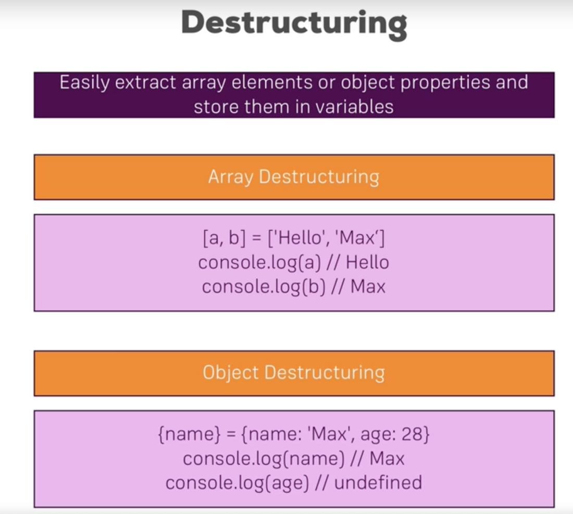

const myObj = {
name: 'Max',
age: 28
}
const {name,age} = myObj; …............>destructuring to access the properties as a vataibles;
console.log(name); // prints 'Max'
console.log(age); // prints undefined
console.log(myObj);

Passed By value and Passed by Reference of Objects:

When we pass the object by reference any manipulations to this object could reflect back all the way back to its initialization. We could prevent this by-passing value using spread operator.

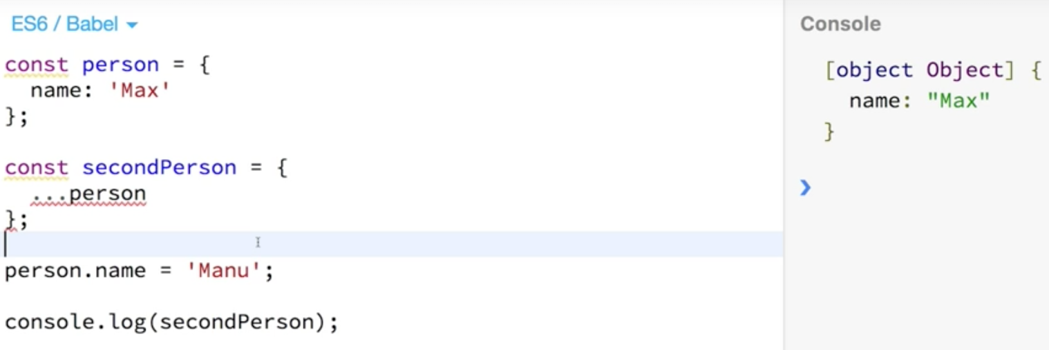

Module 3 : Building a react App

Dependency Management Tools: Npm or yarn
Bundler: Webpack
Compiler: Babel +Presets (Can be integrate with webpack)
Development server

We can also create this environment by a small tool that’s developed by the React developer community. (Create React app)

Lecture 27: Using Create React App

Just like how we create angular app using cli we have a tool ‘Create React App’ that does the same.

Run this command to install crate react-app on u r machine
1. sudo npm install create-react-app –g
2. create-react-app react-complete-guide
3. run npm start

The index.js file has access to the root element div in index.html and this mount the react app root component <APP>.Just like how angular bootstraps the AppModule in index.html.

App.csss is not scoped or linked to App.js but it’s a global style sheet.

Basic React JSX code sample:

We should have a render() function that implements the JSX .

Class App extends Component {
msg ='Pooppy';
render() {
return (
<div className="App">
<p><h1>Amazing React App</h1></p>
</div> . );
// the same thing can be written as
return React.createElement('div',null,React.createElement('p',null,React.createElement('h1',null,this.msg)));
}}
export default App;
Always try to use the JSX code instead of React.creteElement.
The code in JSX looks like HTML but not HTMl, for eg ..we have css ‘class’ in HTMl but in JSX we have ‘className’.

Creating a Functional Component:

In react we can create a functional Component that returns the JSX code.

Eg;

Creating a functional Component. that return JSX code. We must import React in that file. And must export it to access it in other files.
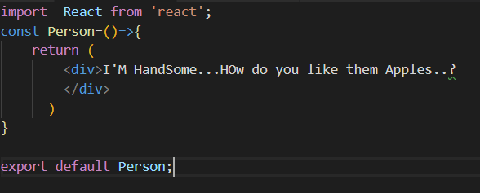

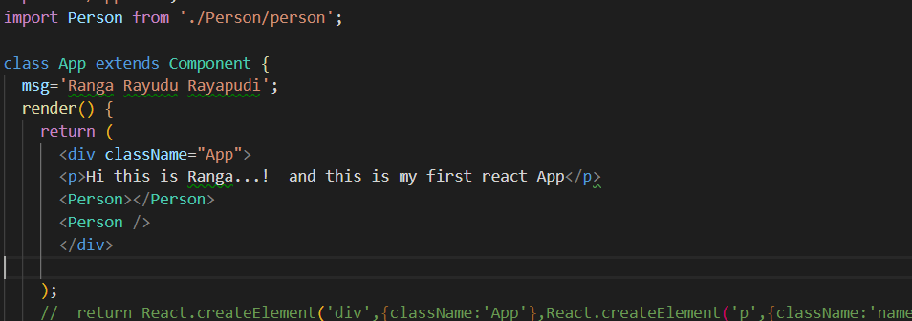

JSX is NOT HTML but it looks a lot like it. Differences can be seen when looking closely though (for example className in JSX vs class in "normal HTML"). JSX is just syntactic sugar for JavaScript, allowing you to write HTML code instead of nested React.createElement(...) calls.
When creating components, you have the choice between two different ways:
- Functional components (also referred to as "presentational", "dumb" or "stateless" components - more about this later in the course) => const cmp = () => { return <div>some JSX</div> } (using ES6 arrow functions as shown here is recommended but optional)
- class-based components (also referred to as "containers", "smart" or "stateful" components) => class Cmp extends Component { render () { return <div>some JSX</div> } }

Adding Dynamic Content to the JSX template:

We can add dynamic content to the JSX using ‘{}’.... like how we have {{}} in angular 4.

Working with Props:
Just like passing values to input in angular her we can add properties (attributes) to the class or JSX template we render.
We call that as props in react.
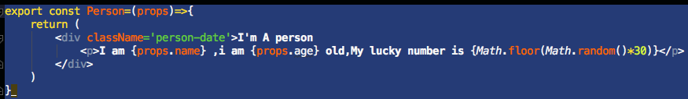
We access those values as {props.name} or {props.value};
In html we pass something as: name=”” and age=””
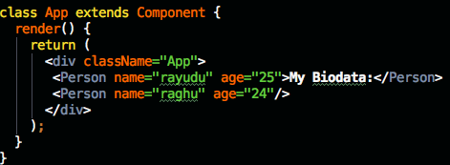
Understanding the Children Property:
In the above we saw that we have a ‘data:->MY Biodata’ passed between the starting and ending of the html tags.
This ‘data’ we can use in the Component as {props.children}.
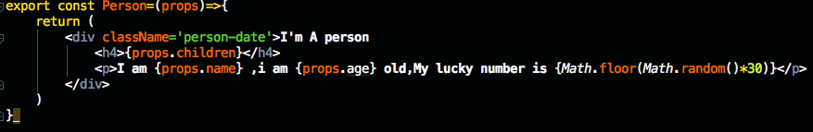
Here data is not only limited to text but also we can insert other components or other html elements like:---> similar to the ngContent tag in Angular 4.
If no content is added between the tags its undefined when the component is rendered.

Understanding and Using states:
State is only manages inside and is only used in class that extends Component.
Whilst props allow you to pass data down the component tree (and hence trigger an UI update), state is used to change the component, well, state from within. Changes to state also trigger an UI update.
Example:
NewPost Component:
class NewPost extends Component { // state can only be accessed in class-based components!
state = {
counter: 1
};
render () { // Needs to be implemented in class-based components! Needs to return some JSX!
return (
<div>{this.state.counter}</div>
);
}
}
Here, the NewPost component contains state . Only class-based components can define and use state. You can of course pass the state down to functional components, but these then can't directly edit it.
state simply is a property of the component class, you have to call it state though - the name is not optional. You can then access it via this.state in your class JSX code (which you return in the required render() method).
Whenever state changes (taught over the next lectures), the component will re-render and reflect the new state. The difference to props.js, that this happens within one and the same component - you don't receive new data (props ) from outside!.

Lecture 41: Handling Events with Methods:
In react to handle the events we add fucntion :
Syntax to bind the function to JSX template
onClick={this.switchUser};
but not onClick={this.switchUser()};
If we add the () the function gets called when the DOM is actually rendered.
https://reactjs.org/docs/events.html#supported-events

Lecture 42: Using the useState() hook for state manipulation.
We could use functional components instead of tradition classes/components. In 16.8 we have hooks and we can create creates using functional classes.
Its basically a function used in react to use in functional components. We no longer has states and no render method just like how we have function components but just return method.
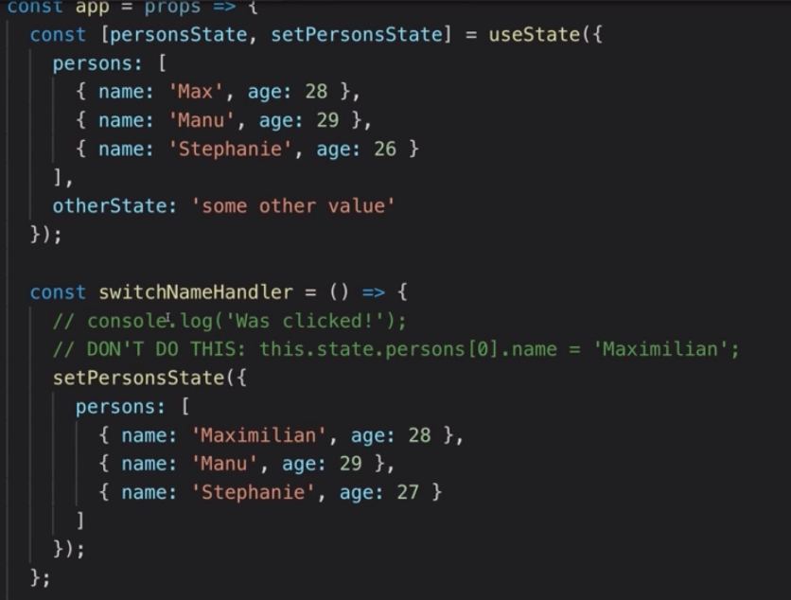
We use the initial state in the JSX.
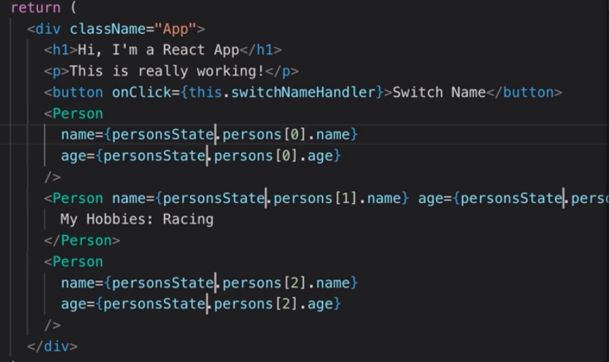

One example is using useState() hook. We pass the current state object and this returns an array with two elements & can use array destructuring to assign the values to array and in every function, we can pass the new state to the second element in useState hook.
We can use useState() as many times as we can.
Similarly, we have many useXXXX functions that can be used.
But always use class bases components as it’s the established way of creating components in react.
Lecture 43: Functional(stateless) vs Class(stateful) Components.
Any components which are just functional(props) receiving classes only render what they are supposed to do. They do not manipulate the application state. They just should render the dynamic content.
Only few specific components change the states and are called ‘Containers’. Classes which extends components and implements ‘setState’ are such componets.
Lecture 44: passing method reference between the component
Just like how we can add properties in the <tag > we can also send reference to the methods in component and can be acess with props.methodname();

<Person name={this.state.person[0].name} age={this.state.person[0].age} click={this.switchUser}></Person>

In Person class we acess this click property using props.
<p onClick={props.click}>I am {props.name} ,i am {props.age} old,My lucky number is {Math.floor(Math.random()*30)}</p>
To pass the arguments we use .bing(this,’arg1’) in the JSX.
<Person name={this.state.person[0].name} age={this.state.person[0].age} click={this.switchUser.bind(this,'poduidgugfh')}></Person>
There also another way to pass the arguments we can use ES6 arrow function ‘anonymous function and pass arguments.
<Person name='Trient Corporation' age='20' click={() => this.switchUser('Apple')}></Person>
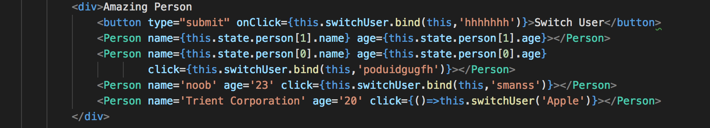
Lecture:45: Adding Two-way Binding.
We add another prop to react to the value changes.
In Person component.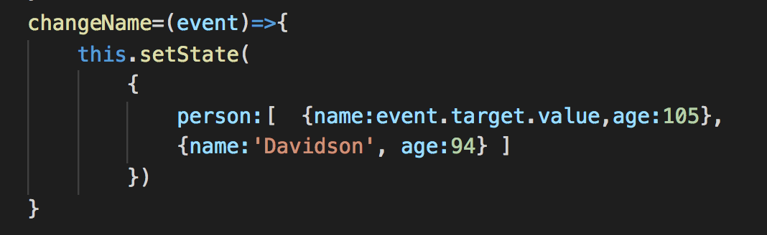
Two way binding always follows ‘value’ with ‘OnChange’ attributes. We can use the event to update the changes to the input and set the value of the input as the {props.name}.
Lecture:46: Adding styling with style sheets./
Simply create the style sheet and import it to the JS file. Webpack allows us or enable to refer the code to do so.
Lecture:50: Rendering JSX Conditionally
In react everything is JavaScript. We can render the conditionally on DOM by returning the HTML elements if a condition is met. The condition has to be evaluated or written inside the render method but not inside the return statement.
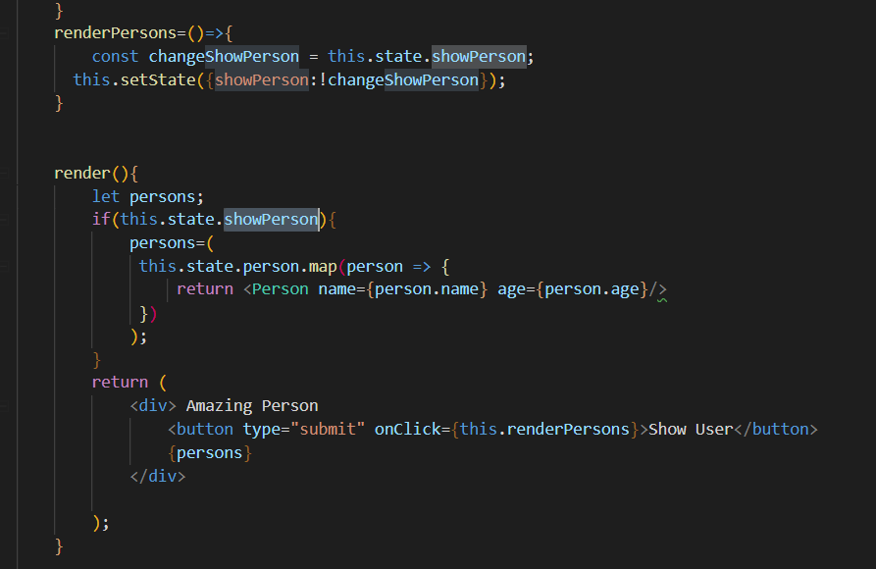
The above code renders the list items conditionally and use javascript map function to iterate and render the list on the dom. We have to dynamically update the boolean calling setState .

Lecture: 159 : Reaching out to Web Using Axios
Axiso uses native javascript promises like .then();

Lecture !90: React Router
We use npm install --save react-router react-router-dom.

Now wrap the app.js with react-router dom.

Lecture: 251 : Redux & State Management.
npm install --save redux
npm install –save react-redux to connect react to redux
Managing state can get complex as the application grows.

Component dispatches actions and reaches reducers and reducers update the store. Once the store is updated it emits all triggers all subscription whenever it changes, and the component subscribes to these subscriptions and updated the component.

Connect matchtateToProps, matchDispatchToProps to the component.
We use createStore and user <Provider /> to provide the store at the app level and to combine reducers we use combineReducers to join multiple reducers together.
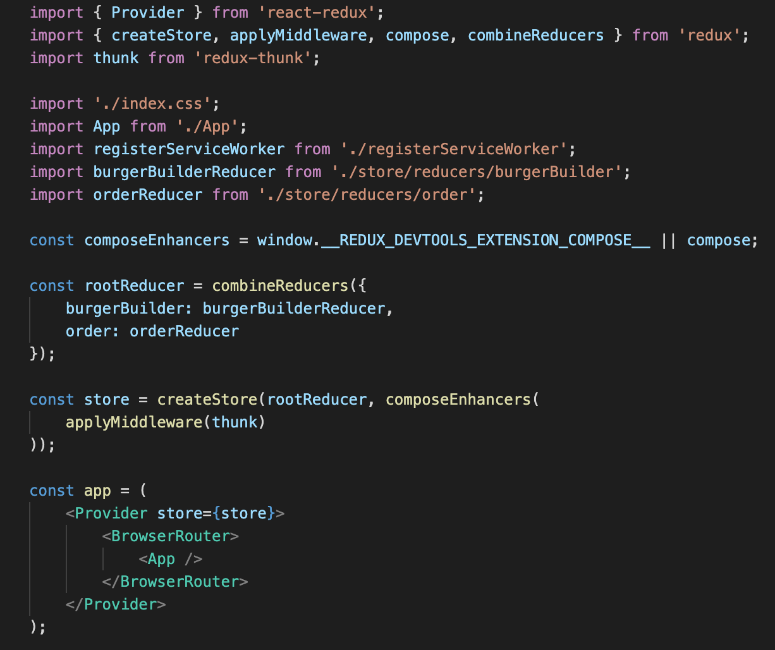
To updating or changing the arrays with using filter & use spread operators.
Lecture 289: Handling Asynchronous code using Redux Thunk
Use redux thunk, a middle ware to handle asynchronous code in React.
Action Reducers are used to run async code and Pure reducers apply sync code.

Tailwind CSS: (2019)
- It does not provide components like bootstrap btns. But Provide utility class that we can customize and add to html.
- Efficient and customization
- Performance(faster) – Dead code elimination – remove unused css during build.
- Community support.

Tailwind Cheat Sheet : https://nerdcave.com/tailwind-cheat-sheet
Tailwind Documentation (v3): https://v3.tailwindcss.com/docs

React 19

Lecture: 354: Testing React App
Testing react app using jest. Its recommended by react-create app. And also use react test utills.

GraphQL

Best graphQl notes to refer to know how GraphQl works.

https://www.howtographql.com/advanced/5-common-questions/
https://www.howtographql.com/react-apollo/0-introduction/

What and why GraphQL ?
Stateless, client independent API for exchanging data with higher query flexibility and is typed query language.
Advantages
- No more endpoints to retrieve only subset of data.
- Less endpoints and less complex query params to fetch data.
- No more redundant data from Api and less computational work to parse data and render on front end.
We only have on endpoint (api path : /graphQl) and we add query structure always with post call. No get call with GraphQL. Only POST request for everything.
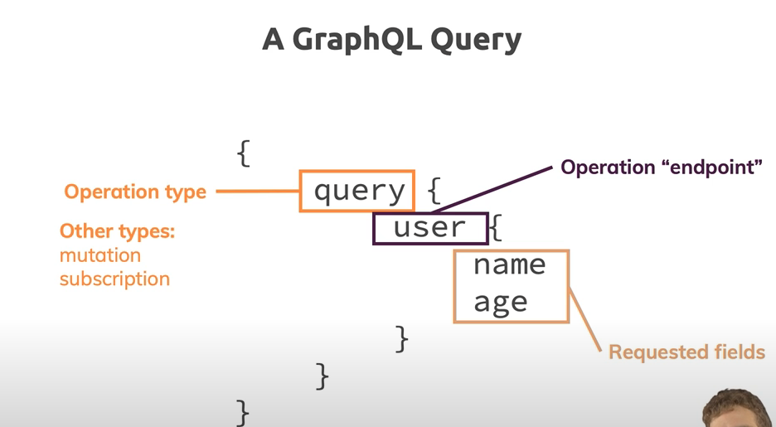

OperationTypes in GraphQL
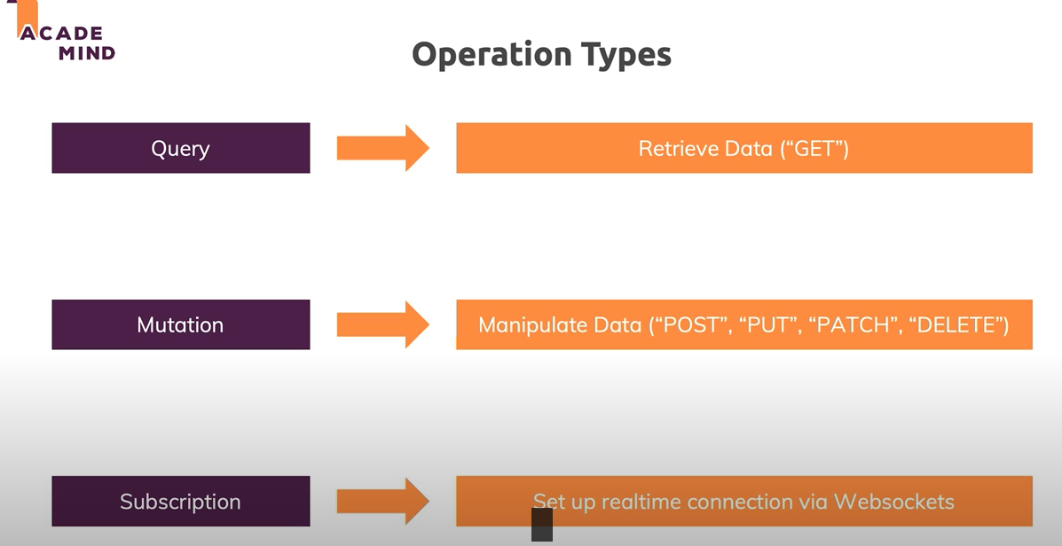

GraphQl Big Picture Compared to REST apis
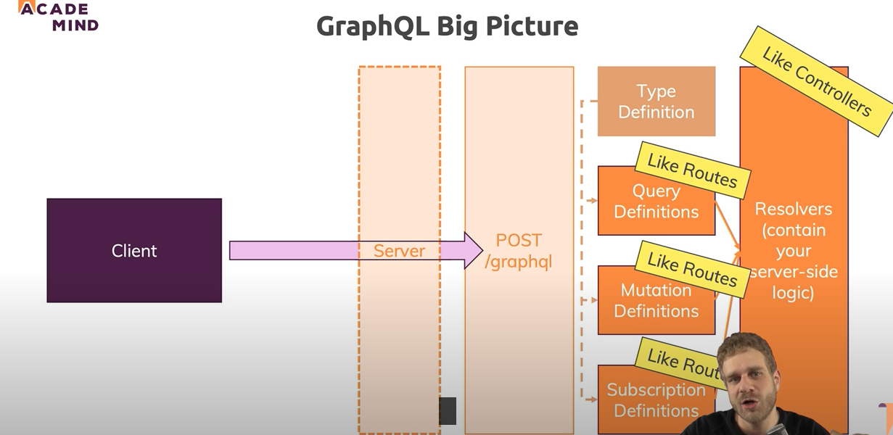
Necessary package:
1. Express-graphql – middle ware to allow point to a schema and forwad to right query parser and the write resolver and routes
2. graphQl – to define schema to follow specification and parse our shema to use with express-graphql.

Federated GraphQl: (Federated Sub Graphs)
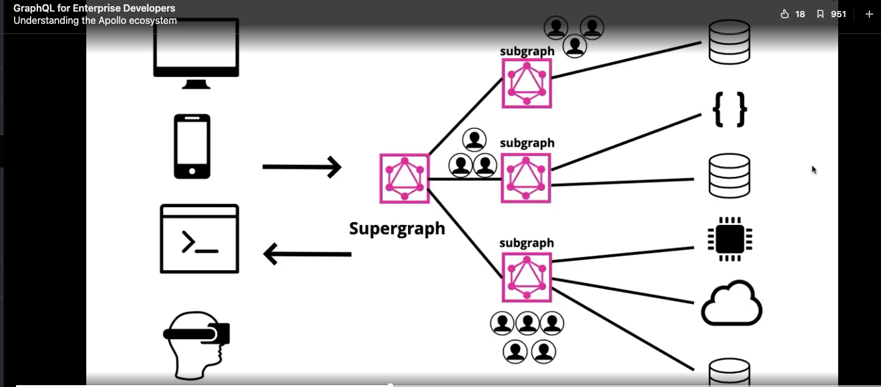

Each subgraph or microservices runs on different server. They are called subgraphs and GraphQl api gteway (Also called Supergraph) manages the communication between these subgraphs.
Below Code snippet shows how sub graphs are created. You can see that we are calling buildSubgraphSchema with their own typedefs and resolvers.
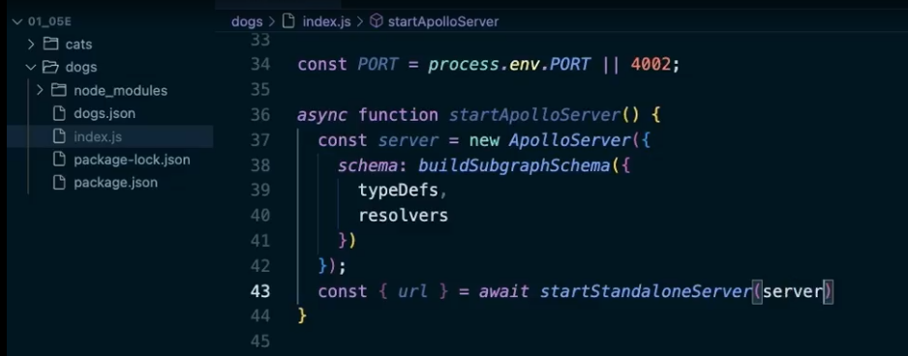

Rover cli to work better with schemas. Refer apollo graphql studio explorer. Using rover command we can manage subgraphs and schemas in the graphs.
We can use rover commands to introspect the exposed graphql schemas locally .
“rover subgraph introspect http://localhost:4001” –out

@defer -> Graphql query is as slow as the data is retrieved. So we can create the fragments of data that can be deferred to later before getting necessary priority data.
and @stream -> If me have list of data that is being returned e can stream the data and to get initial count of certain amount of data.

